Elements Attributes

Styles Formatting Quotation’s

Block & Inline File Paths Layout Responsive Computercode

Semantics Entities Emoji’s Charset URL-Encode Image center

GITHUB (REPOSITORY)

GOIE add commits GITHUB-LINK LINK SHORT(GIT.IO) 1LINE-CODE

BLAME-BUTTON

GITHUB

CODE-ISSUES-PULL REQUESTS- ACTIONS-PROJECTS0 WIKI-SECURITY-INSIGHTS-SETTINGS

HTML GRAPHICS

1. HTML Canvas
2. HTML SVG

HTML MEDIA (AUDIO VIDEO)

HTML Plug-ins

HTML **YouTube** (Autoplay +mute) Playlist Loop

### **YouTube** - Autoplay + Muted

<iframe width="420" height="315"  
src="https://www.youtube.com/embed/tgbNymZ7vqY?autoplay=1&mute=1">  
</iframe>

**HTML MEDIA**

The HTML <video> Element

To show a video in HTML, use the <video> element:

### **Example**

<video width="320" height="240" controls>  
  <source src="movie.mp4" type="video/mp4">  
  <source src="movie.ogg" type="video/ogg">  
Your browser does not support the video tag.  
</video>

## HTML <video> Autoplay

To start a video automatically, use the autoplay attribute:

### **Example**

<video width="320" height="240" autoplay>  
  <source src="movie.mp4" type="video/mp4">  
  <source src="movie.ogg" type="video/ogg">  
Your browser does not support the video tag.  
</video>

**Note:** Chromium browsers do not allow autoplay in most cases. However, muted autoplay is always allowed.

Add muted after autoplay to let your video start playing automatically (but muted):

### **Example**

<video width="320" height="240" autoplay muted>  
  <source src="movie.mp4" type="video/mp4">  
  <source src="movie.ogg" type="video/ogg">  
Your browser does not support the video tag.  
</video

## HTML Video - Methods, Properties, and Events

The HTML DOM defines methods, properties, and events for the <video> element.

This allows you to load, play, and pause videos, as well as setting duration and volume.

There are also DOM events that can notify you when a video begins to play, is paused, etc.

### **Example: Using JavaScript**

Play/Pause Big Small Normal

Video courtesy of [Big Buck Bunny](https://www.bigbuckbunny.org/).

[Try it Yourself »](https://www.w3schools.com/html/tryit.asp?filename=tryhtml5_video_js_prop)

For a full DOM reference, go to our [HTML Audio/Video DOM Reference](https://www.w3schools.com/tags/ref_av_dom.asp).

## The HTML <audio> Element

To play an audio file in HTML, use the <audio> element:

### **Example**

<audio controls>  
  <source src="horse.ogg" type="audio/ogg">  
  <source src="horse.mp3" type="audio/mpeg">  
Your browser does not support the audio element.  
</audio>

## HTML <audio> Autoplay

To start an audio file automatically, use the autoplay attribute:

### **Example**

<audio controls autoplay>  
  <source src="horse.ogg" type="audio/ogg">  
  <source src="horse.mp3" type="audio/mpeg">  
Your browser does not support the audio element.  
</audio>

**Note:** Chromium browsers do not allow autoplay in most cases. However, muted autoplay is always allowed.

Add muted after autoplay to let your audio file start playing automatically (but muted):

### **Example**

<audio controls autoplay muted>  
  <source src="horse.ogg" type="audio/ogg">  
  <source src="horse.mp3" type="audio/mpeg">  
Your browser does not support the audio element.  
</audio>

## Browser Support

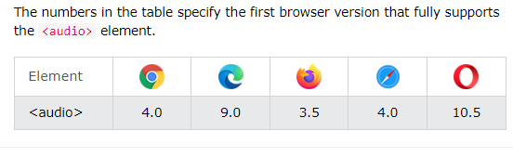

## HTML Audio - Media Types

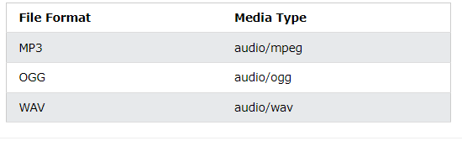

## HTML Audio - Methods, Properties, and Events

The HTML DOM defines methods, properties, and events for the <audio> element.

This allows you to load, play, and pause audios, as well as set duration and volume.

There are also DOM events that can notify you when an audio begins to play, is paused, etc.

For a full DOM reference, go to our [HTML Audio/Video DOM Reference](https://www.w3schools.com/tags/ref_av_dom.asp).

## HTML Audio Tags

